**ME 111 Engineering Drawing**

**Section of solids Wednesday Batch**

**Q.1** A cone with base 75 mm diameter and axis 80 mm long is resting on its base on H.P. It is cut by a section plane perpendicular to the V.P., inclined at 45º to the H.P. and cutting the axis at a point 35 mm from the apex. Draw the front view, sectional top view, sectional side view and true shape of the section. [20 marks]

{Note: Please don’t cut the marks if the student divides the base circle into 6 or 8 equal number of parts. Dividing the circle into 4 equal parts is not to be accepted as 4 points are not sufficient to give the proper views of sections.}

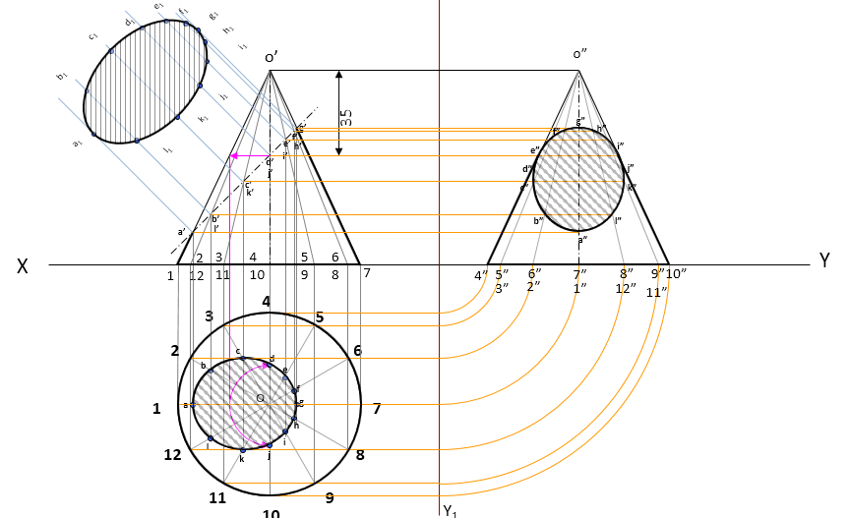

**Q.2** A pentagonal pyramid, base 25mm side and axis 50 mm long is lying on one of its triangular faces on the HP with the axis parallel to the VP. A vertical section plane, whose HT bisects the top view of the axis and makes an angle of 30º with the reference line, cuts the pyramid removing its top part. Draw the top view, sectional front view of remaining solid and true shape of the section. [30 marks]



